Time Series HW 4

Kylie Taylor

Wed, April 3, 2019

Dr. Zervou

**1)** I will be using the data provided on the ln real GDP per capita, federal funds rate and CPI for the duration of this problem.

The following plot is of the three parameters of interest. There is a very obvious unit root in the CPI. I doubt there is cointegration present here.



The following plot is of the first differenced series. The covariance stationary series was created by taking the first difference of the logged variables.



The VAR model we want to estimate follows

We assume that the contemporaneous effects make the B matrix lower triangular. This means that ${}_{1,2}=0,$ ${}_{1,3}=0,$ ${}_{2,3}=0$. This means that the contemporaneous effect of CPI on ln GDP rate is zero, CPI on federal funds is zero, and ln GDP on federal funds rate is zero. This is given that this theory is correct, which impulse response functions will verify. This this fits our short run restrictions which ensure that B is lower triangular, and we can use Cholesky’s decomposition to find the covariance matrix, D.

The graphs of the impulse response functions for a VAR with 2 lags is below.



The plot above reveals that the following variables had contemporaneous effects greater than zero: federal funds rate on CPI, and federal funds rates on ln GDP.

The following variables have a contemporaneous effect not statistically different than zero: ln GDP on CPI, ln GDP on federal funds rate, CPI on ln GDP, and CPI on federal funds rate.

This matches up with the theory written above, except that the contemporaneous effect of lnGDP on CPI is zero, when it was expected to not be zero. This verifies the ordering of variables written above.

The following matrix is the estimation of the Cholesky matrix, which describe the forecast errors.



Since the ordering of variables from the first VAR, (FFR, lnGDP, CPI), proved to be valid, I will propose a new ordering of the VAR structure. A new ordering I will try is (lnGDP, CPI, FFR). I would now be imposing short run restrictions (B has to be lower diagonal) that imply the lnGDP has a contemporaneous effect on both CPI and FFR, and that CPI has a contemporaneous effect on FFR.

I found that using this ordering, the impulse response functions remain the same as before. This makes sense because they will reveal the contemporaneous and long run effects regardless of order. What did not remain the same was the Cholesky decomposition matrix, which is provided below.



This is an effect of the ordering, because although we restricted the B matrix to be lower triangular, the findings from the VAR and economics reveal that it may not be truly lower triangular. This effects the Cholesky decomposition matrix by resulting in different values for the entries.

DO-File

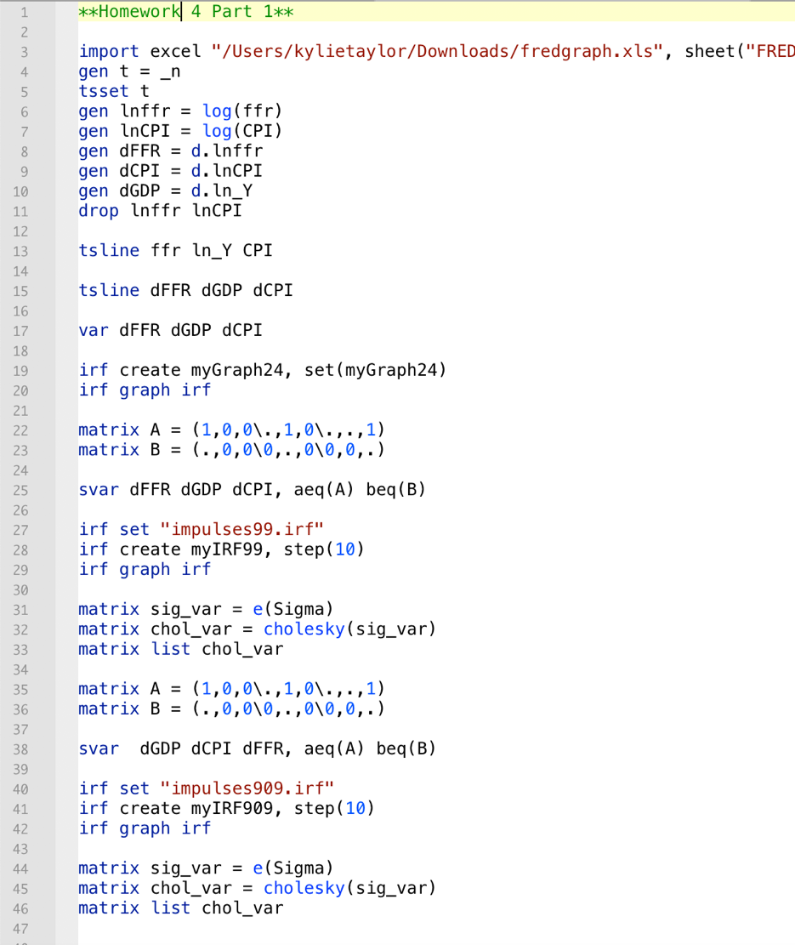

**2)**

We often use VARs in macro time series instead of IV or individual equations because VARs allows us to model shocks as a system of equations and determine reverse causation. This is useful for determining contemporaneous and long run effects of multiple macro variables in a single framework. We have recursive identification, or able to identify the errors of one variable without needing to know errors of another variable.

With VAR we are able to get the correlation structure of data, can do macro modeling without pretending to have a priori theory, and given the structure, make identification assumptions what shocks are.

This is a 2x2 structural VAR(1) model that I would like to estimate

This is the reduced from for that model.

I need to define and estimate the reduced form version, because this allows for B to be invertible, which means I can compute the equations, and if B is lower triangular, it means that I can compute the Cholesky decomposition matrix, which gives me the covariance matrix.

I want to identify the covariance matrix, because the error terms are the “surprise” movements in the variables and reveal information about the shocks. I would not be able to solve this covariance matrix if B is not lower diagonal, since Cholesky decomposition only holds for inverse B matrices that are lower triangular.

I would use the Cholesky decomposition and short run restrictions to identify my model by assuming that the contemporaneous effect of GDP on unemployment rate is zero. This would ensure that B is lower triangular. Once I have the B matrix, I would take the inverse, which will also be lower triangular. Using this marix, I would calculate the Cholesky matrix, Ω = $B^{-1}D(B^{-1})'$, which renders the matrices B and D, our matrices of interest!

These are the specific equations that relate the parameters you want to estimate from the structural model, with the parameters you actually estimate from the reduced form model.

The structural parameters are

The reduced form parameters are

The equation that relates the parameters is

Impulse response functions give us the response of the endogenous variables to shocks. IRFs give the effect of

We derive the structural IRFs from the reduced form ones by

Jorda IRFs may be different from VAR IRFs, because VARs approximate the data globally where the impulse responses are functions of multi-step forecasts, whereas Jorda IRFs consider local approximations for each forecast horizon. Advantages to the Jorda IRFs is that it can be estimated by a single-equation OLS, provide joint inference for coefficients, and are robust to misspecification.